Project Design Phase-II
Technology Stack (Architecture & Stack)
Date | 01 October 2026
Team ID | SWTID-2026-8116
Project Name | AI FitTrack API
Maximum Marks | 4 Marks

Technical Architecture:
The architecture diagram below is followed by Table-1 (components and technologies) and Table-2 (application characteristics).
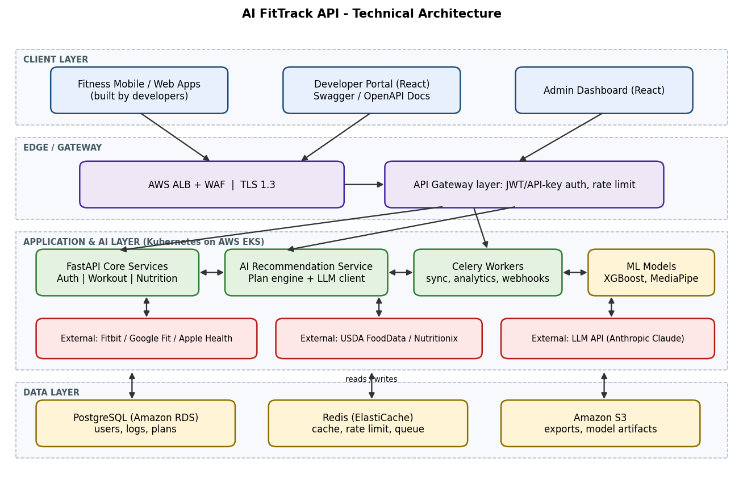
Table-1 : Components & Technologies:
S.No | Component | Description | Technology
1 | User Interface | The API has no end-user screen. Developers use a portal for keys, docs and usage; administrators use a dashboard. | React, HTML, CSS, JavaScript; Swagger UI (OpenAPI 3)
2 | Application Logic-1 | Core services: authentication, profiles, workout and nutrition logging, goals. | Python 3.12, FastAPI, Pydantic, SQLAlchemy
3 | Application Logic-2 | AI recommendation service: builds plans from user history and goals and requests explanations. | Python, scikit-learn, XGBoost; prompt builder
4 | Application Logic-3 | Background jobs: wearable sync, analytics, webhook delivery. | Celery workers with Redis broker
5 | Database | Relational data: users, keys, workouts, meals, sleep, plans, consents. | PostgreSQL 16
6 | Cloud Database | Managed database with backups and read replicas. | Amazon RDS for PostgreSQL
7 | File Storage | Data exports, imported Apple Health files, model artifacts. | Amazon S3 (encrypted buckets)
8 | External API-1 | Pull activity, sleep and heart-rate data from wearables. | Fitbit Web API, Google Fit / Health Connect; Apple Health file import
9 | External API-2 | Food search and nutrition facts. | USDA FoodData Central, Nutritionix
10 | External API-3 | Natural-language explanation of plans. | LLM API (Anthropic Claude)
11 | Machine Learning Model | Load-progression and calorie models; pose-based form checks for squat and push-up. | XGBoost, scikit-learn; MediaPipe Pose
12 | Infrastructure (Server / Cloud) | Local: Docker Compose (API, Postgres, Redis).  Cloud: containers on Kubernetes, 3 API pods (2 vCPU, 4 GB each), autoscaling to 10. | Docker, AWS EKS, GitHub Actions CI/CD, Terraform
Table-2: Application Characteristics:
S.No | Characteristics | Description | Technology
1 | Open-Source Frameworks | Open-source frameworks used across API, jobs, ML and portal. | FastAPI, SQLAlchemy, Celery, PostgreSQL, Redis, scikit-learn, XGBoost, MediaPipe, React
2 | Security Implementations | Encrypted traffic and storage, hashed secrets, scoped access, input validation, rate limiting, audit logs, dependency scanning. | TLS 1.3, AES-256, Argon2, SHA-256 key hashing, OAuth 2.0 / JWT, RBAC, AWS WAF, OWASP API Top 10, Dependabot
3 | Scalable Architecture | 3-tier design with a stateless API tier; separate workers for heavy jobs so each part scales on its own. | Kubernetes HPA, Celery, RDS read replicas
4 | Availability | Replicas in two availability zones behind a load balancer, health probes, automated failover for the database. | AWS ALB, EKS multi-AZ, RDS Multi-AZ
5 | Performance | Target p95 under 300 ms (standard) and 5 s (AI). Cache food search and repeated reads; async I/O; pagination; connection pooling. | Redis, async FastAPI, PgBouncer, CloudFront for docs and portal
References:
- C4 model: https://c4model.com/
- AWS Architecture Center: https://aws.amazon.com/architecture
- FastAPI documentation: https://fastapi.tiangolo.com/

